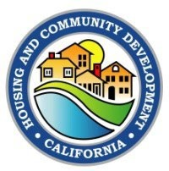

[Grantee or Subrecipient Name]
Section 3 Project Implementation
FORM 7 – SECTION 3 BUSINESS OUTREACH FORM

Please complete this form to determine if your business can qualify as a Section 3 Business. Businesses that meet the criteria listed below will be contacted by [Grantee or Subrecipient Name] Section 3 Coordinator to complete a Section 3 Business Application and asked to provide additional documentation to verify their status as a Section 3 Business. Instructions to complete this form are provided at the end of the form. After completing this form, submit back to the Grantee or Subrecipient identified at the top of this form.

What is Section 3?
Section 3 is a provision of the Housing and Urban Development Act of 1968 (24 CFR Part 75) that requires recipients of certain HUD financial assistance, to the greatest extent possible, to provide job training, employment, and contract opportunities to low- or very low-income residents, in connection with projects and activities in their neighborhood.

A business can qualify as Section 3 if it meets one of the following criteria:
- It is at least 51% owned and controlled by low- or very low-income persons;
- Over 75% of the labor hours performed for the business over the past three-month period were performed by workers who met at least one of the criteria below; or
- It is at least 51% owned and controlled by current public housing residents or residents who currently live in Section 8-assisted housing.

Workers must meet one of the following criteria for a business to qualify as Section 3 under item B above:
- (Section 3 Worker) Reside within one mile of the Section 3 project (or, if fewer than 5,000 people live within one mile of the Section 3 project, within a circle centered on the Section 3 project that is sufficient to encompass a population of 5,000 people according to the most recent U.S. Census);
- Be a HUD YouthBuild participant (see definition in instructions below; or
- Income for the previous or annualized calendar year is below 80% of the current area median income for the area in which the worker resides. (Use the worker’s annual gross income based on AMI for a single-person household.) HUD income limits can be found at https://www.huduser.gov/portal/datasets/il.html.) (See instructions.)

Subcontractor Information
Company Name:
Contact Person: Identify the point of contact to discuss Section 3 status determination.
Address:
City: State: Zip:
Phone: Email:

☐ I have reviewed the above information and my business MAY QUALIFY as a Section 3 Business. Please contact me about completing an application. (See additional notes in instructions below.)
☐ I have reviewed the above information and my business DOES NOT QUALIFY as a Section 3 Business.

Signature of Business Owner Date
Note: Grantee or Subrecipient provides the information below.
Please return completed forms to: (Information to be provided by Grantee or Subrecipient)
Grantee or Subrecipient Name Section 3 Program
Address
City, State ZIP
Phone| Email

Instructions for completing Form 7 – Section 3 Business Outreach

Definitions

Low-or very low-income persons: Defined as having income at or below 80 percent of the area median income (AMI) for the area in which the worker resides.

Section 8-assisted housing: Officially called the Section 8 Housing Choice Voucher Program, this program is run by the United States Department of Housing and Urban Development (HUD) and provides financial assistance for rent. Section 8 rentals can exist anywhere landlords choose to participate – not just in low income or affordable housing projects.

Section 3 Worker: Any worker who currently fits, or when hired fit, at least one of the following categories, as documented within the past five years:
- The worker’s income for the previous or annualized calendar year is below the income limit established by HUD.
- The worker is employed by a Section 3 Business Concern.
- The worker is a YouthBuild participant.

Section 3 Project: A housing rehabilitation, housing construction, and other public construction projects assisted under U.S. Housing and Urban Development (HUD) programs that provide housing and community development financial assistance when the total amount of assistance to the project exceeds $200,000 of housing and community development financial assistance.

The project is defined as the site or sites together with any building(s) and improvements located on the site(s) that are under common ownership, management, and financing.

Service area or neighborhood of the project: Determined by a one-mile radius around the Section 3 project site if this radius includes minimum population of 5,000 people. When fewer than 5,000 people live within a mile of the Section 3 project, the size of the service area is increased so that it is sufficient to encompass a population of 5,000 people, according to the most recent U.S. Census. The example provided below demonstrates the one-mile radius around the project area (worksite) expanded until the radius includes the minimum 5,000 population.
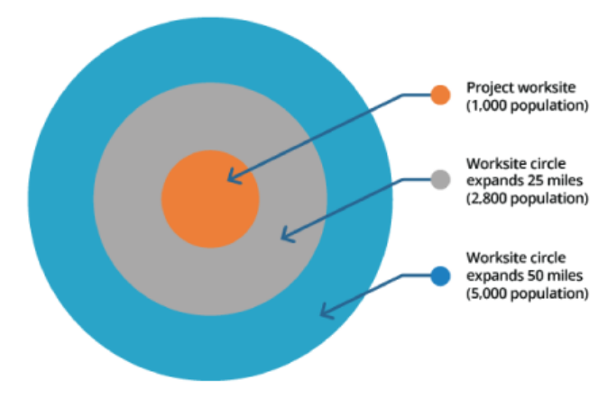

YouthBuild: Community-based apprenticeship program administered by the U.S. Department of Labor that provides job training and educational opportunities for at-risk youth ages 16-24 who have previously dropped out of high school.

Subcontractor Information Section

Complete this section with the information requested. Please indicate the point of contact to discuss Section 3 status determination for your business.

The information on the following page provides assistance to determine the status of low-or- very low-income persons, persons with income at or below 80 percent of the AMI.

Determining if income meets low- or very-low-income status

Please view the following link to access the income limits for your residential county or metropolitan area: Income Limits are found here: State and Federal Income, Rent, and Loan/Value Limits | California Department of Housing and Community Development. Be sure to use the limits posted in the section titled: CDBG, HOME and NHTF/HHC Article I - Income, Value, Subsidy, and Rent Limits

NOTE: Income is based on individual income.

- Open link to California's federal program Income Limits as noted above

The page will look like the picture below.
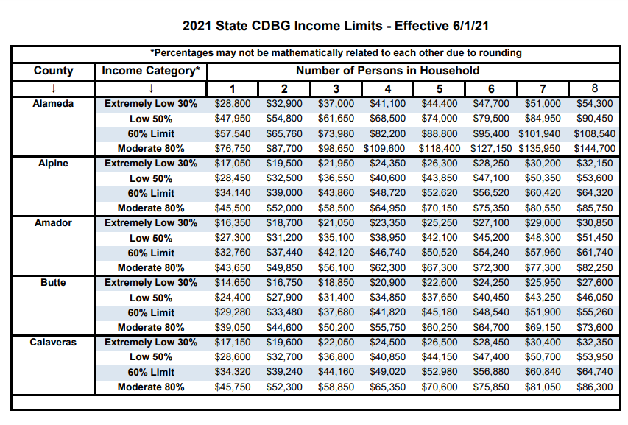

- Scroll down the list to locate the county where you live.

The third row from the top of the page indicates the number of persons in a household. You will only use the column that indicates a household for one (1) person to determine where your income falls within the provided income limits.

- Determine where your income falls within the range of income limits for the county where you live.
For example: If you live in Alameda County, follow the income limits provided under the one (1) person household. If your income is below the income limit for Moderate 80%, $76,750, as indicated for Alameda County, in this column for one (1) person household then you are considered to meet the criteria for a low-to-very low-income status.

